Journal of Analytical Psychology

XVII International Conference
14 - 17 October 2027
Split, Croatia

The Space Between:
Its Limits and Possibilities, Collapse and Metamorphosis
in the Analytic Vessel and the World

Sponsored by The Society of Analytical Psychology



Artist: Lindsey Harris

MAIN PROGRAMME
THURSDAY, 14th OCTOBER

Pre-conference Workshops and Clinical Discussion Groups

9.15am: WELCOME

9.30-11.00am: First Workshop Choice (workshops are offered twice, participants choose 2 out of 3)

WORKSHOP 1: Donald Kalsched: “Recognizing Defensive Patterns in Dreams as a Key to Developing Affect-competency”

WORKSHOP 2: Chiara Tozzi: “The Enemy, the Friend and the Beyond”

WORKSHOP 3: Mark Saban: “Exploring the Transindividual Field in Analysis”

11.00am: MORNING COFFEE BREAK

11.30-1.00pm: Second Workshop Choice

1.00pm – 2.00pm: LUNCH

2.00-3.30pm: Clinical Discussion Groups: the experience of the analyst in times of rapid change and uncertainty:

Psyche, Soma, and the Psychoid in the Consulting Room.
Chairs: Lara Lagutina and Arthur Niesser

Cultural complex and collective pressures.
Chairs: Amanda Dowd and Carolyn Bates

AI intrusions into the analytic space.
Chair: John Merchant

Talking about Gender and Sex.
Chair: Robert Tyminski

3.30-4.00pm: AFTERNOON TEA

4.00-5.00pm: Plenary

7.00-10.00pm Screening of the film “Tuesday” by the Croatian filmmaker Daina O Pusic.
After the viewing Renos Papadpoulos will be speaking with Daina Pusic, followed by an open engagement of the audience.

FRIDAY, 15th OCTOBER

8.00-9.00am: Social dreaming matrix with Ali Zarbafi and Barbara March

Conference Day 1: The Space Between – Containment and its Vicissitudes in the Analytic Vas I: its collapse, survival, and possible emergence and/or metamorphosis

9.30am: WELCOME

9.45-10.45am: Jay Barlow: “The Reticent Child”

10.45-11.15am: MORNING COFFEE

11.15-12.15pm: Lara Lagutina: “Shared Dreaming on the Edge of Collapse: When Interpretation Is too Much and Holding is not Enough”

12.15-1.30pm: LUNCH

1.30-3.00pm: Breakout panels

3.00pm: AFTERNOON TEA

3.30-5.00pm: Breakout panels

SHORT BREAK

5.15-6.15pm: Donald Kalsched: “Revisioning Analytical Psychology: Early Infant Studies and Attachment Trauma”

6.30pm: DRINKS RECEPTION

SATURDAY, 16th OCTOBER

8.00-9.00am: Social dreaming matrix with Ali Zarbafi and Barbara March

Conference Day 2: The Space Between – Containment and its Vicissitudes in the Analytic Vas I: moments of meeting, enactments, self-disclosure, somatisation and psyche/soma confusions

9.30am: WELCOME

9.45-10.45am: Martin Schmidt: “When the Frame Trembles: Self-disclosure and Enactment in the Anatomy of Sudden Change”

10.45-11.15am: MORNING COFFEE

11.15-12.15pm: Nora Swan-Foster: “Singing the Mole’s Song: Spontaneous Images in the Underworld of Unrepresented States of Being”

12.15-1.30pm: LUNCH

1.30-3.00pm: Breakout panels

3.00pm: AFTERNOON TEA

3.30-5.00pm: Breakout panels

7.00pm: SATURDAY NIGHT: CONFERENCE GALA DINNER

SUNDAY, 17th OCTOBER

8.00-9.00am: Social dreaming matrix with Ali Zarbafi and Barbara March

Conference Day 3: The Space Between – Treatment in a politically fractious world: pressures on and intrusions into the analytic vas from cultural and political upheaval, conflict, collective and intergenerational trauma

9.30am: WELCOME

9.45-10.45am: Renos Papadopoulos: “Coniunctio Oppositorum Revisited: Polarisation, Destructiveness and Transformation”

10.45-11.15am: MORNING COFFEE

11.15-12.15pm: Antonio Lanfranchi: “Witnessing at the Limits of Disavowal: Analysis during the Destruction of Gaza”

12.15-1.30pm: LUNCH

12.45-13.45: Closing Conference Plenary

General information

Venue and Accommodation
The conference will be held at the Cornaro Hotel in Split. It is situated centrally, next to the Diocletian Palace and within easy walking distance from the waterfront.
We negotiated a special deal with the hotel for 60 conference participants. At the cost of 195 EUR per night it includes a half-board arrangement with accommodation in a comfort double/twin Room (single use) and a buffet menu, either for lunch or dinner. The conference dinner will be held on the beautiful roof terrace of the hotel and it can be part of the arrangement with no additional charge. To make use of this special offer, please email japeditors@thesap.org.uk
The regular conference room rate (comfort double/twin room) including breakfast for single use is 150 EUR per room per night, for double use 225 EUR.

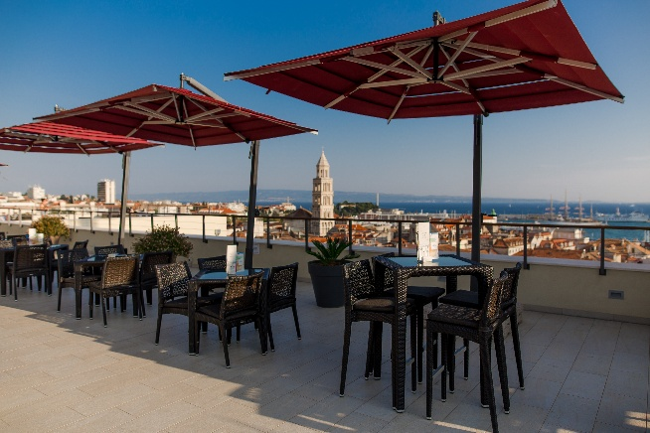

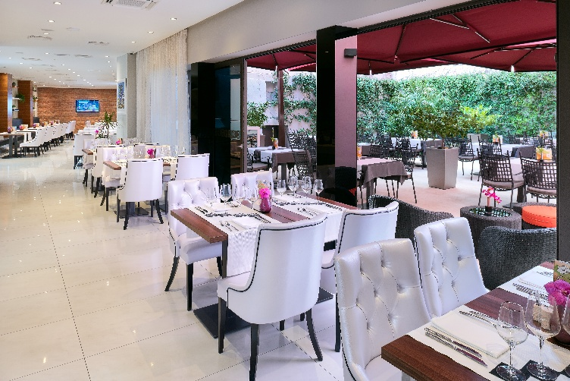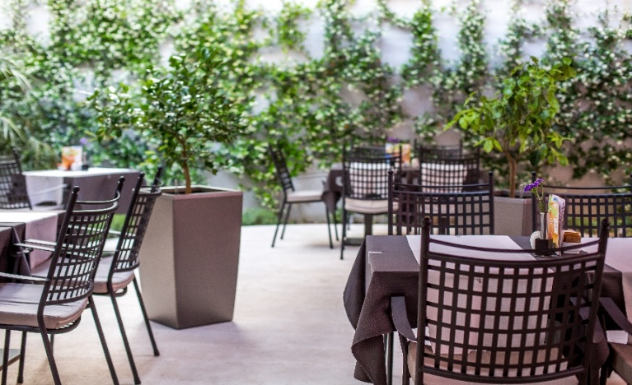

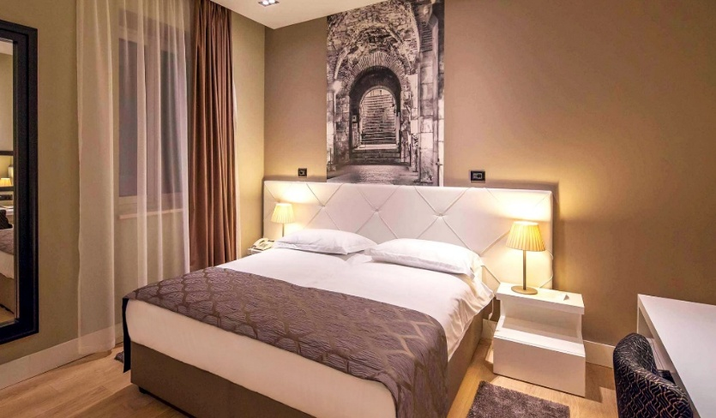
Split – Tourism

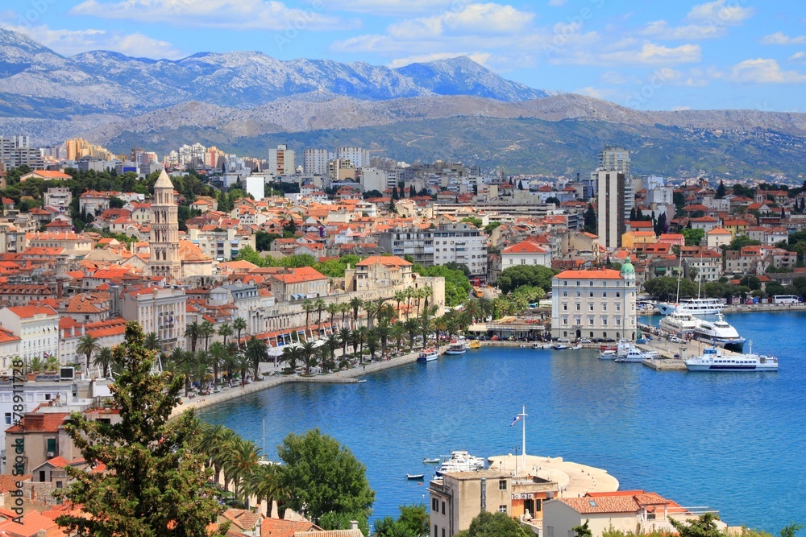

Split is a highly attractive city from a touristic point of view. Situated on the eastern shore of the Adriatic Sea, it is the second largest city in Croatia (after the capital Zagreb).
The city was founded as a Greek colony in the 3rd or 2nd century BCE. In 305 CE, it became the site of the Palace of the Roman emperor Diocletian. This historic core is recognised as a UNESCO World Heritage Site since 1979. The Port of Split connects to various islands in the vicinity. The University of Split contributes to the bustling life of the city.
The climate is generally mild. The average temperature in October is around 21 degrees with a low probability of rain. The average water temperature at this time of year is over 20 degrees which is warm enough for swimming.
More information is provided online: Visit Split | Split

Travel

Split airport connects to many international locations. There is a regular bus link to the centre of the town, close to the hotel. There is a trainline between Zagreb and Split.
Booking information
Fees for the main conference
Early Bird General Admission before 30.4.2027 £390.00
Early Bird Concessionary Rate before 30.4.2027 ££240.00
General Admission after 30.4.2027 £430.00
Concessionary Rate after 30.4.2027 £280.00
Fees for the pre-conference
Early Bird General Admission before 30.4.2027 £120.00
Early Bird Concessionary Rate before 30.4.2027 ££80.00
General Admission after 30.4.2027 £150.00
Concessionary Rate after 30.4.2027 £110.00
We will consider requests for a fee reduction in individual cases for participants from lower income countries
Registration Link: Will be available soon

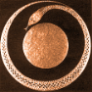 | 

